28/09/2016

Application for monitoring the status of the garbage containers

Synopsis

**ITSMAP16-02**

**Authors:**

Pierre Biojoux – 201601360

Quentin Studeny – 201601160

Junyoung Bang – 201600883

Joonas Luukkanen – 201601318

# 1. Table of contents

1. Table of contents 2

2. Vision 3

ITIPRJ quick project summary 3

Main goal 3

3. Use cases 3

3.1 Use cases diagram 3

3.2 Use case: Authenticate 4

3.3 Use case: Check status of garbage bins 4

4. Early Design Overview 5

# 2. Vision

This project goes hand in hand with our ITIPRJ project work.

## ITIPRJ quick project summary

This project consists in an Internet of Things (IoT) garbage bins, which transmit their full or empty status through 3G. The purpose of this project is to optimize garbage collection through this data transmission.

The IoT garbage bin has a microprocessor, and a sensor, used to detect the current status of the bin (full/empty).

The user should be able to interact with the system to get statuses of the different bins, visualize this information on a map, to get their locations, update the occupancy rate of a garbage container and check the weather to know what equipment they need.

## Main goal

Thus our main goal is to transmit the information gathered through a user interface, in a form of an android app. To make a use of a database, we will use additional features such as data history or login and user base would serve to enhance user experience.

Persisting data would then be implemented through the login feature, with the stored user id and encrypted password.

Phone-sized and tablet-sized screen will be supported.

We might propose route suggestions to optimize the garbage collecting process, but this feature is likely to be too complex for the added value, and hence will be a low priority.

For background tasking, we could use bin status updates or some automated refresh feature.

The main activity would still be the visualization on a map. It would display symbols or other means to pinpoint the bin location, and present the bin’s status in some sort of way.

Other activities would include specific information files on bins, login page.

# 3. Use cases

## 3.1 Use cases diagram

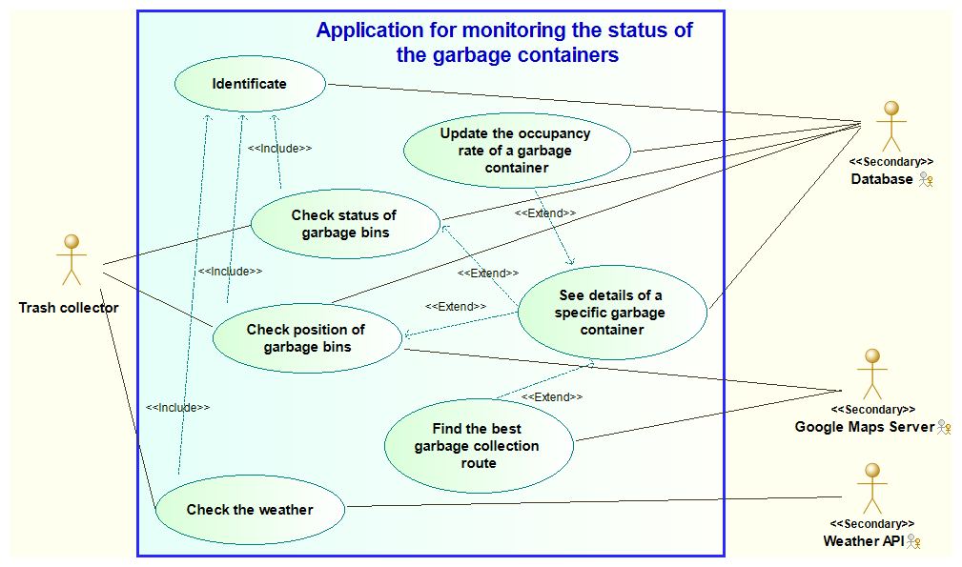

## 3.2 Use case: Authenticate

|  |  |
| --- | --- |
| **Name** | **Authenticate** |
| **Goals** | Access the application |
| **Preconditions** | Have an internet connection |
| Trash collector needs a smartphone |
| **Post-condition** | The user's smartphone and the server are connected |
| **Nominal Scenario** | 1: The app opens the activity of the authentication |
| 2: User fills his login and his password |
| 3: User chooses the button "Log in" |
| 4: The server checks his login and his password |
| 5: The server allows the app to open the next activity |
| **Alternative Scenario** | 2.a User decides to quite the app |
| **Error Scenario** | 4.a The login or the password is incorrect -> The app shows the message "Invalid password or login" |

## 3.3 Use case: Check status of garbage bins

|  |  |
| --- | --- |
| **Name** | **Check status of garbage bins** |
| **Goals** | Know how full are garbage bins emptied |
| **Preconditions** | All the system has to work |
| Have an internet connection |
| Trash collector needs a smartphone |
| **Post-condition** | The user's smartphone and the system are connected |
| **Nominal Scenario** | 1: The app opens the activity of the main menu |
| 2: User select "Check the status" |
| 3: The app opens the list of garbage bins |
| 4: User consults the list |
| **Alternative Scenario** | 2.a User decides to sign out |
| 2.b User chooses another option of the menu |
| 4.a User decides to return to the menu |
| **Error Scenario** | 3.a App can't update data -> The app shows the message "We can't update data, check your internet connection" |

# 4. Early Design Overview

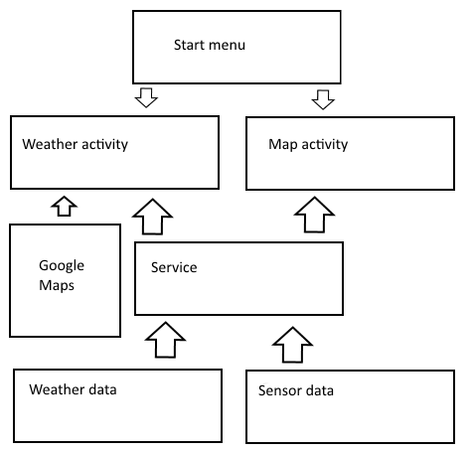Basis for our application is to meet requirements specified. In picture x our planned application architecture is described.

Our plan is to have main menu which leads to desired function in application. Background service will keep data flowing to our application from weather API and sensor. To fulfill requirements for assignment data storage using database is possible.

We have received examples and education on every part of our application. Largest risk factor developing our application will be making service and getting sensor to work in time. To counter act these risk factor it is possible to use simulated data for testing/returning application. Since our assignment is tied to our project work from other course scheduling will be easier.